Personal Finance Analytics Dashboard
Backend API Specification

PROJECT REPORT

Course: Advanced Web Technologies (AWT)
Assessment: Midterm Lab — Express.js Application Implementation
Date: April 2026

Submitted By:
Hamza Farooq (FA23-BSE-038)
Hamza (FA23-BSE-037)

1. Project Overview
The Personal Finance Analytics Dashboard API is a RESTful backend application built with Express.js and MongoDB for managing personal finances. It provides comprehensive features for:

- User Authentication — Secure registration and login with JWT tokens
- Transaction Management — Full CRUD for income and expense tracking
- Budget Management — Monthly category-based budgets with real-time spent tracking
- Savings Goals — Goal setting with contribution tracking and auto-completion
- Reports & Analytics — Advanced analytics using MongoDB aggregation pipelines
- Notifications — Budget alerts, goal reminders, and transaction confirmations

Key Highlights
35+ API endpoints  Across 7 resource modules | JWT Authentication  Stateless, secure token-based auth
MongoDB Aggregation  Server-side analytics pipelines | Joi Schema Validation  Validated on all inputs
Centralized Error Handling  Typed error classes | Security First  Helmet.js, CORS, rate limiting

2. Project Architecture
The application follows the MVC (Model-View-Controller) architectural pattern with clear separation of concerns:

Directory Structure
finance-dashboard-api/
├── src/
│ ├── app.js
│ ├── config/
│ │ ├── database.js
│ │ └── env.js
│ ├── models/ (5 models)
│ │ ├── User.js | Transaction.js | Budget.js
│ │ ├── SavingsGoal.js | Notification.js
│ ├── controllers/ (7 controllers)
│ │ ├── authController.js | userController.js
│ │ ├── transactionController.js | budgetController.js
│ │ ├── goalController.js | reportsController.js
│ │ └── notificationsController.js
│ ├── routes/ (7 routers)
│ ├── middleware/ (6 files)
│ │ ├── auth.middleware.js | authorization.middleware.js
│ │ ├── validation.middleware.js | errorHandler.middleware.js
│ │ └── logger.middleware.js | rateLimiter.middleware.js
│ ├── validators/ (5 files)
│ └── utils/ (3 files)
├── .env | package.json | README.md

Request Flow
Client Request
→ Helmet (Security Headers) → CORS → Body Parser (JSON)
→ Logger Middleware → Rate Limiter (100 req/15min per IP)
→ Route Handler
→ Auth Middleware (JWT verification)
→ Controller (business logic)
→ Validator (Joi schema) → Model (Mongoose operations)
→ Response Formatter (consistent JSON)
→ Error Handler Middleware (if error thrown)

3. Technology Stack & Dependencies

Package | Version | Purpose
express | ^5.2.1 | Web framework
mongoose | ^9.5.0 | MongoDB ODM
bcryptjs | ^3.0.3 | Password hashing (10 salt rounds)
jsonwebtoken | ^9.0.3 | JWT token generation/verification
joi | ^18.1.2 | Request body validation
helmet | ^8.1.0 | Security HTTP headers
cors | ^2.8.6 | Cross-Origin Resource Sharing
dotenv | ^17.4.2 | Environment variable management
express-validator | ^7.3.2 | Additional input validation
nodemon | ^3.1.14 | Development auto-restart (devDep)

4. Database Design

4.1 User Schema
Field | Type | Constraints
fullName | String | Required, trim, 2-50 chars
email | String | Required, unique, lowercase, regex validated
passwordHash | String | Required, min 6 chars, select: false
role | String | Enum: ['user'], default: 'user'
currencyPreference | String | Enum: PKR/USD/EUR/GBP/AUD, default: PKR
createdAt / updatedAt | Date | Auto-managed by timestamps

Features: Pre-save hook for bcrypt password hashing, comparePassword() instance method, toJSON() excludes passwordHash.

4.2 Transaction Schema
Field | Type | Constraints
userId | ObjectId | Required, ref: User, indexed
type | String | Enum: ['income', 'expense']
amount | Number | Required, min: 0.01
category | String | Required, enum (16 predefined categories)
description | String | Optional, max 500 chars
transactionDate | Date | Required, default: now
paymentMethod | String | Enum: cash / card / bank_transfer

Income Categories: Salary, Freelance, Investment, Bonus, Gift, Other Income
Expense Categories: Food, Transport, Shopping, Utilities, Entertainment, Healthcare, Education, Rent, Insurance, Other Expense
Indexes: {userId, transactionDate}, {userId, category}, {userId, type}

4.3 Budget Schema
Field | Type | Constraints
userId | ObjectId | Required, ref: User
category | String | Required, enum (expense categories only)
monthlyLimit | Number | Required, min: 0.01
spentAmount | Number | Default: 0, calculated via aggregation
remainingAmount | Number | Auto-calculated: monthlyLimit - spentAmount
month | String | Required, format: YYYY-MM (regex validated)

4.4 SavingsGoal Schema
Field | Type | Constraints
userId | ObjectId | Required, ref: User
title | String | Required, trim, max 200 chars
targetAmount | Number | Required, min: 0.01
currentAmount | Number | Default: 0
deadline | Date | Required
status | String | Enum: active / completed / abandoned
progressPercentage | Number | Auto-calculated, 0-100

4.5 Notification Schema
Field | Type | Constraints
userId | ObjectId | Required, ref: User
type | String | Enum: budget_alert / goal_reminder / transaction_confirmation
message | String | Required, max 500 chars
isRead | Boolean | Default: false

5. API Endpoints

5.1 Authentication — /api/auth
Method | Endpoint | Description | Auth
POST | /register | Register a new user, returns JWT | No
POST | /login | Authenticate user, returns JWT | No
GET | /me | Get current user profile | Yes
POST | /logout | Invalidate token (client-side) | Yes
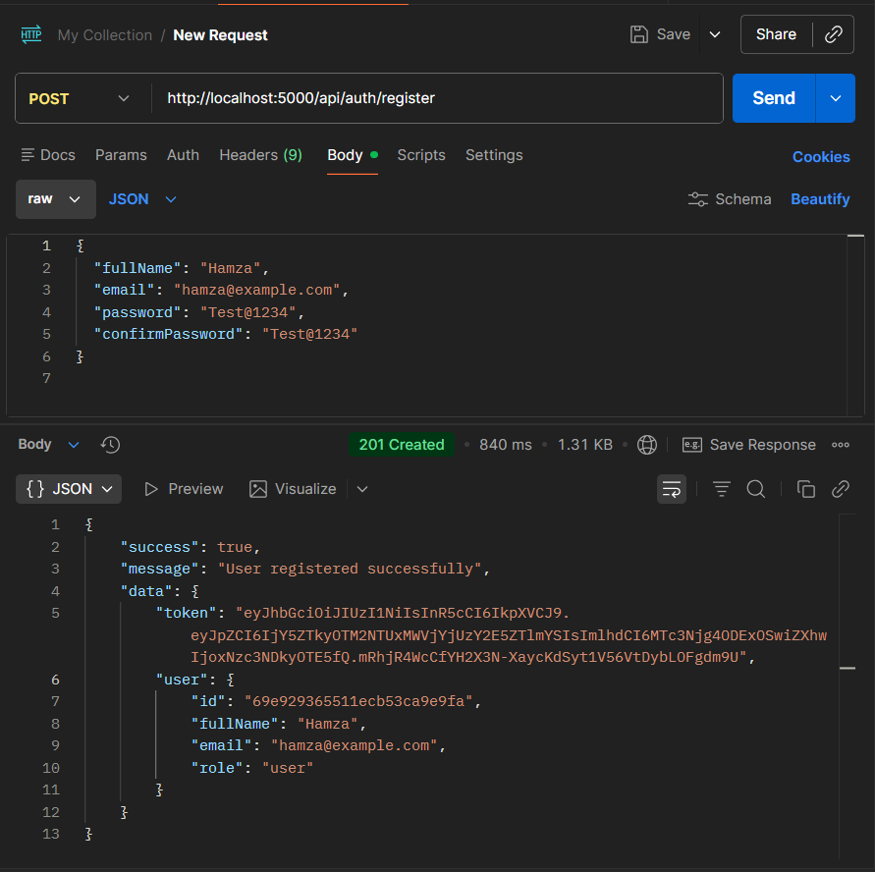
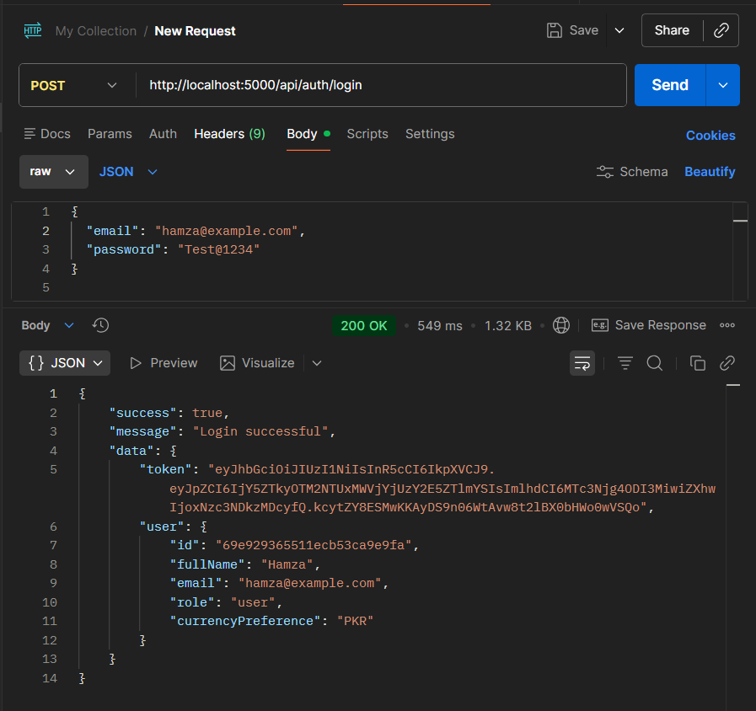

5.2 Users — /api/users
Method | Endpoint | Description | Auth
GET | /:id | Get user profile by ID | Yes
PUT | /:id | Update profile / change password | Yes
DELETE | /:id | Delete account | Yes
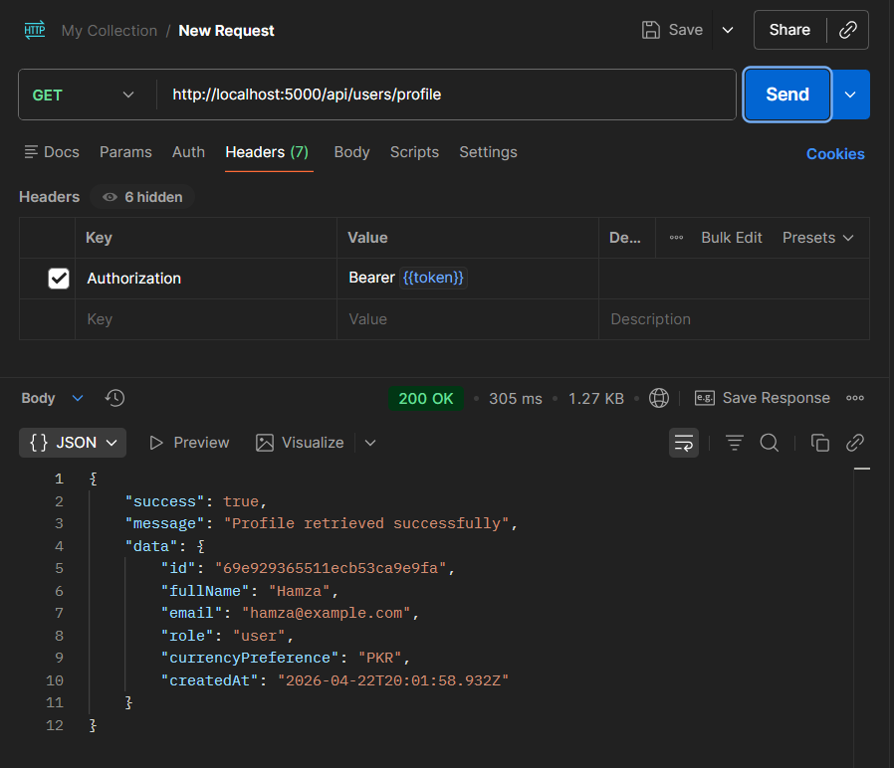
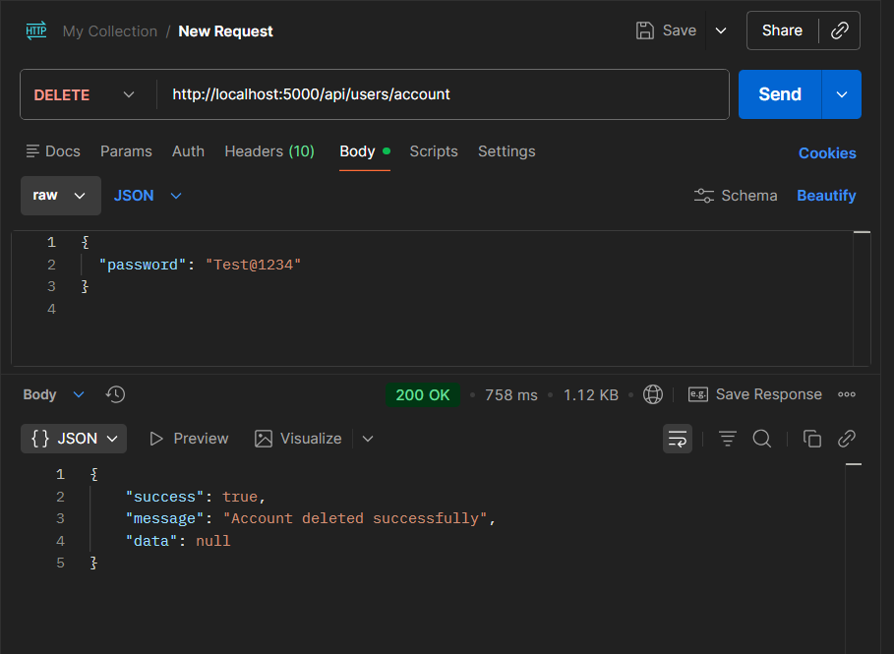

5.3 Transactions — /api/transactions
Method | Endpoint | Description | Auth
GET | / | List transactions (filter, sort, paginate) | Yes
POST | / | Create new transaction | Yes
GET | /:id | Get transaction by ID | Yes
PUT | /:id | Update transaction | Yes
DELETE | /:id | Delete transaction | Yes
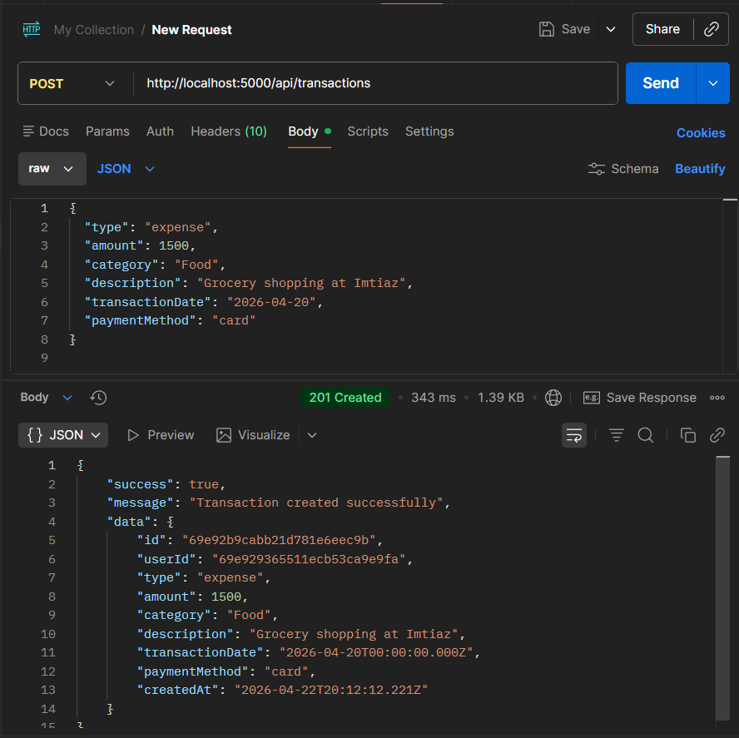
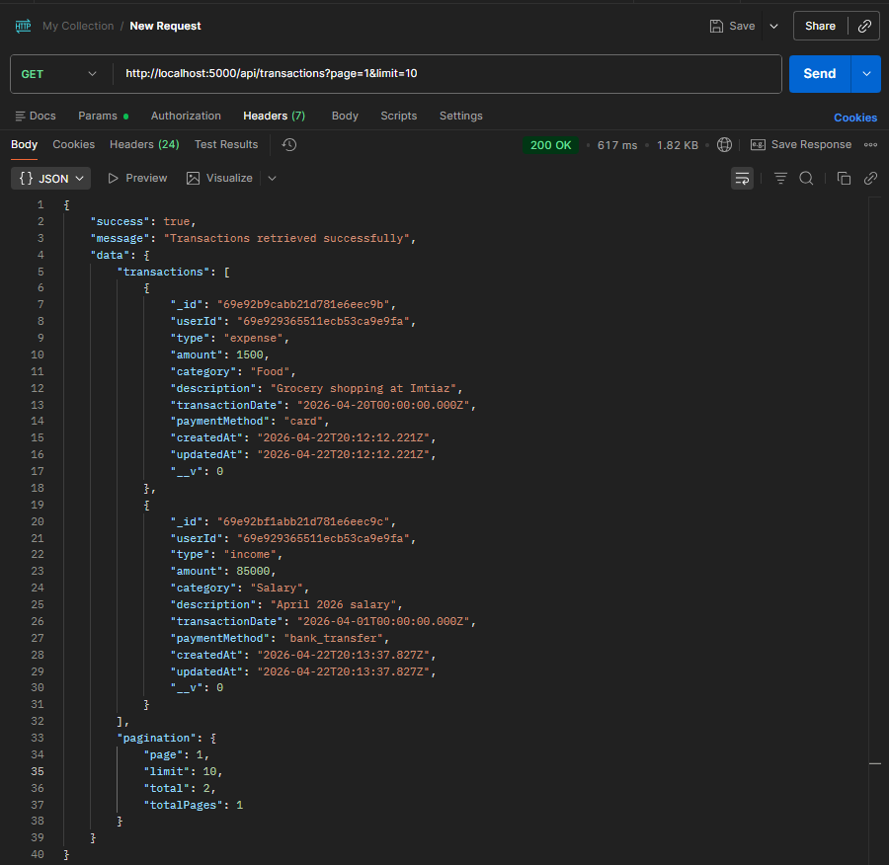
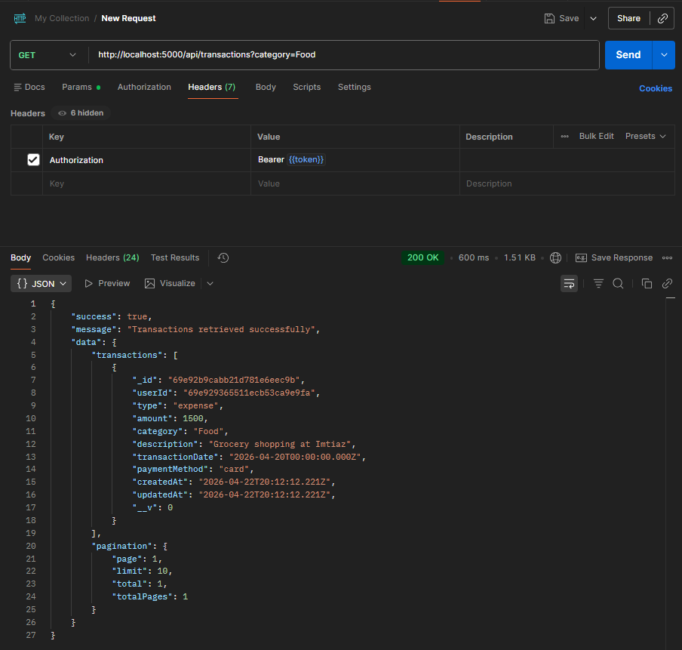
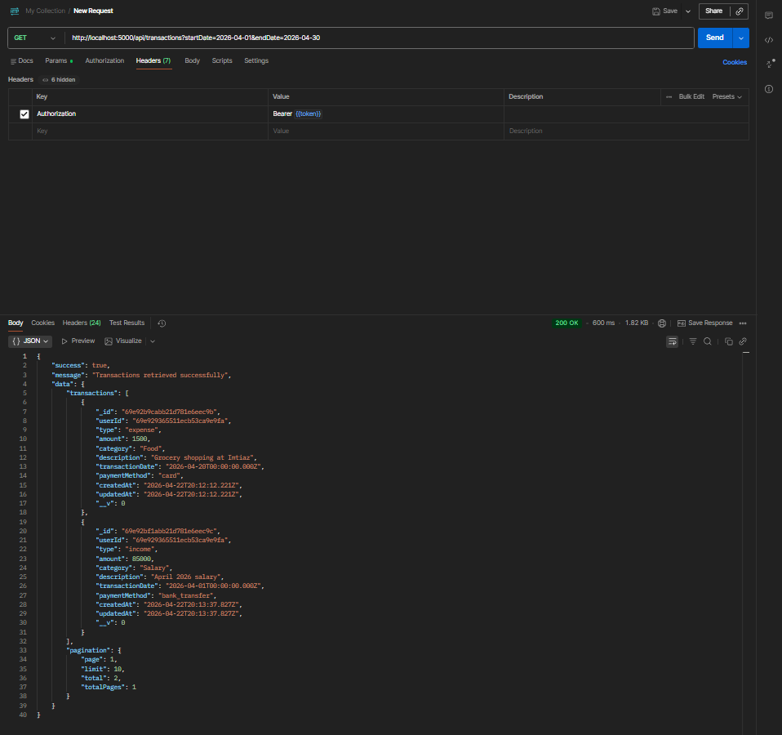

5.4 Budgets — /api/budgets
Method | Endpoint | Description | Auth
GET | / | List budgets with spent amounts | Yes
POST | / | Create budget for category/month | Yes
GET | /:id | Get single budget | Yes
PUT | /:id | Update monthly limit | Yes
DELETE | /:id | Delete budget | Yes

5.5 Savings Goals — /api/goals
Method | Endpoint | Description | Auth
GET | / | List all goals with progress | Yes
POST | / | Create new savings goal | Yes
GET | /:id | Get single goal | Yes
PUT | /:id | Update goal details | Yes
DELETE | /:id | Delete goal | Yes
POST | /:id/contribute | Add contribution to goal | Yes

5.6 Reports — /api/reports
Method | Endpoint | Description | Auth
GET | /monthly-summary | Income vs expense summary | Yes
GET | /category-breakdown | Spending by category | Yes
GET | /income-expense-trend | Month-over-month trend | Yes
GET | /savings-progress | All goals progress summary | Yes

5.7 Notifications — /api/notifications
Method | Endpoint | Description | Auth
GET | / | List all notifications | Yes
PUT | /:id/read | Mark notification as read | Yes
PUT | /read-all | Mark all as read | Yes
DELETE | /:id | Delete notification | Yes

6. Middleware Implementation

6.1 Auth Middleware
- Extracts Bearer token from Authorization header
- Verifies JWT signature using JWT_SECRET
- Attaches req.user = { id: userId } for downstream use
- Returns 401 UnauthorizedError for missing or invalid tokens

6.2 Authorization Middleware
- Verifies resource ownership: req.user.id must match resource userId
- Returns 403 ForbiddenError for unauthorized access attempts

6.3 Validation Middleware
- Generic middleware factory: validate(schema) returns a middleware
- Runs Joi schema against req.body
- Returns 422 with field-level error details on failure

6.4 Error Handler Middleware
- Global catch-all for all errors passed via next(error)
- Handles: Mongoose ValidationError, CastError, duplicate key (11000), JWT errors
- Environment-aware: verbose stack traces in development, minimal in production

6.5 Logger Middleware
- Logs every request: method, URL, status code, response time, user ID
- ANSI color-coded: green=2xx, yellow=4xx, red=5xx
- Sanitizes request bodies in development (passwords redacted)

6.6 Rate Limiter Middleware
- In-memory rate limiter (no external dependencies)
- Configurable: 100 requests per 15 minutes per IP
- Sets X-RateLimit-Limit, X-RateLimit-Remaining, X-RateLimit-Reset headers
- Returns 429 when limit exceeded

7. Authentication & Authorization

JWT Authentication Flow
1. User registers → password hashed with bcrypt (10 salt rounds) → stored in DB
2. User logs in → password compared → JWT generated (7-day expiry)
3. Client includes token: Authorization: Bearer <token>
4. Auth middleware verifies token → attaches req.user = { id: userId }
5. Controllers access req.user.id to scope queries to the authenticated user

Security Features
- Passwords never stored in plaintext — bcrypt hashing with 10 salt rounds
- passwordHash excluded from queries by default (select: false)
- JWT tokens are stateless — no server-side session storage
- All resource endpoints verify ownership (userId matching)
- Helmet.js adds security headers (XSS, clickjacking, MIME sniffing protection)
- CORS configured for allowed origins and methods
- Rate limiting prevents brute-force attacks

8. Validation Strategy
All user inputs are validated using Joi schemas before processing:

Module | Create Schema | Update Schema | Extra
Auth | email, password (8+ chars), fullName | — | confirmPassword matching
Users | — | fullName, currencyPreference, password change | Current password required
Transactions | type, amount, category, date, paymentMethod | All optional | Category must match type
Budgets | category, monthlyLimit, month (YYYY-MM) | monthlyLimit only | Duplicate prevention
Goals | title, targetAmount, deadline (future) | title, targetAmount, deadline, status | contributeSchema

9. Error Handling & Response Format

Consistent Response Structure
Success Response:
{ "success": true, "message": "Operation successful", "data": { } }

Error Response:
{ "success": false, "message": "Validation failed",
"errorCode": "VALIDATION_ERROR",
"details": { "amount": "Amount must be positive" } }

Typed Error Classes
Class | HTTP Status | Error Code
BadRequestError | 400 | BAD_REQUEST
UnauthorizedError | 401 | UNAUTHORIZED
ForbiddenError | 403 | FORBIDDEN
NotFoundError | 404 | NOT_FOUND
ConflictError | 409 | CONFLICT
ValidationError | 422 | VALIDATION_ERROR
RateLimitError | 429 | RATE_LIMIT_EXCEEDED

10. MongoDB Aggregation Pipelines
The Reports module uses MongoDB aggregation pipelines for efficient server-side data computation:

Monthly Summary Pipeline
[
{ $match: { userId: ObjectId, transactionDate: { $gte, $lte } } },
{ $group: { _id: '$type', total: { $sum: '$amount' }, count: { $sum: 1 } } }
]
Produces: totalIncome, totalExpenses, netSavings, savingsRate

Category Breakdown Pipeline
[
{ $match: { userId: ObjectId, type: 'expense', transactionDate: { $gte, $lte } } },
{ $group: { _id: '$category', total: { $sum: '$amount' }, count: { $sum: 1 } } },
{ $sort: { total: -1 } }
]
Produces: per-category amount, percentage of total, transaction count

Income/Expense Trend Pipeline
[
{ $match: { userId: ObjectId, transactionDate: { $gte: startDate } } },
{ $group: {
_id: { year: { $year: '$transactionDate' }, month: { $month: '$transactionDate' }, type: '$type' },
total: { $sum: '$amount' }
}},
{ $sort: { '_id.year': 1, '_id.month': 1 } }
]
Produces: monthly income/expense data for chart visualization

Environment Variables
Variable | Description | Default
PORT | Server port | 5000
MONGODB_URI | MongoDB connection string | localhost:27017
JWT_SECRET | Secret key for JWT signing | —
JWT_EXPIRY | Token expiration time | 7d
NODE_ENV | Environment mode | development
CORS_ORIGIN | Allowed frontend origin | localhost:3000

13. Conclusion
The Personal Finance Analytics Dashboard API is a fully functional RESTful backend that demonstrates proficiency in:

Skill Area | Demonstration
Express.js | Route handling, middleware chain, error management
MongoDB & Mongoose | Schema design, indexing, aggregation pipelines
Authentication | JWT-based stateless auth with bcrypt password hashing
API Design | RESTful conventions, consistent response formats, pagination
Security | Helmet, CORS, rate limiting, input validation, password hashing
Code Organization | MVC architecture with clear separation of concerns

5 Mongoose Models • 7 Controllers • 7 Route Files • 6 Middleware • 5 Validators • 35+ Endpoints

End of Report

